MACH4METAL

metalworking machinery
Transito 21
6909 DA BABBERICH Netherlands
Tel. +31 (0)316-247123
Fax: +31 (0)316-247956
info@mach4metal.com
www.mach4metal.com

Bank No : 66.52.13.883
IBAN : NL33 INGB 0665 2138 83
BIC : INGBNL2A

Tracto Technik TUBOMAT 642
Processing machine for hydraulic piping
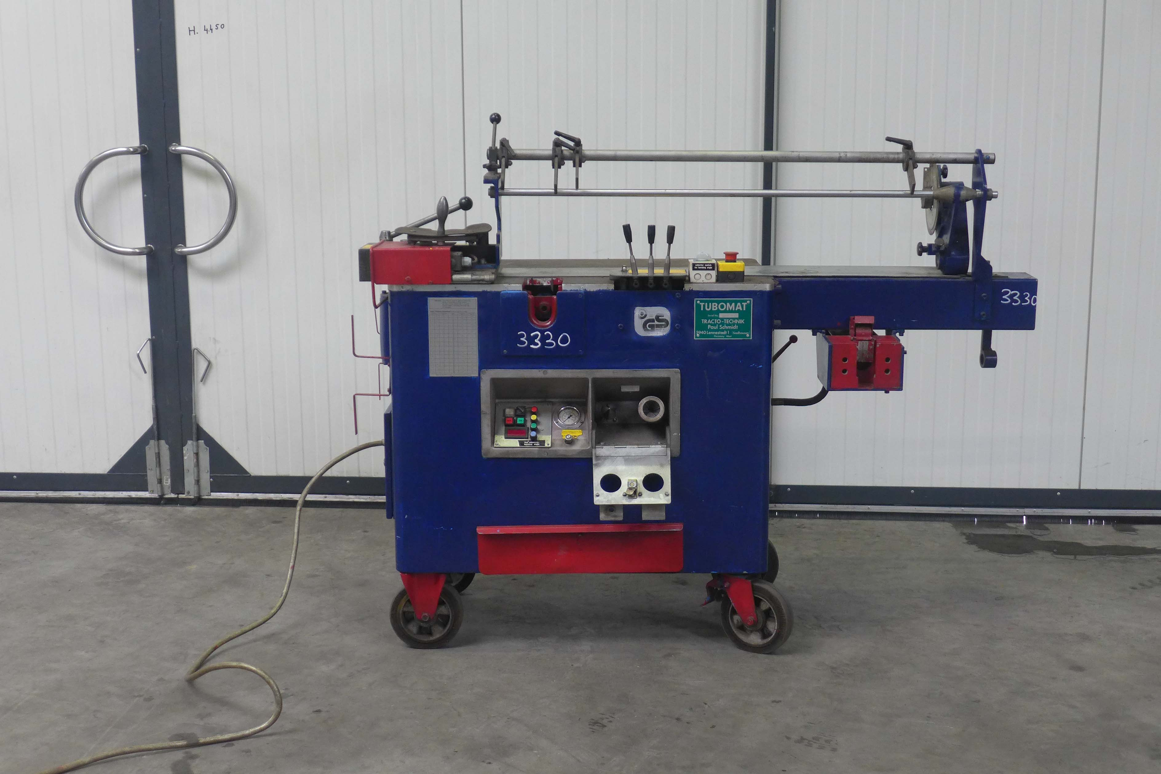
- Make : Tracto Technik Germany
- Typ : Tubomat 642
- Age : 1989
- Serial.No. : 945

- Minimum tube Ø : 6 mm
- Maximum tube Ø : 42 mm
- Maximum radius : 90 mm
- Maximum length : 2.000 mm
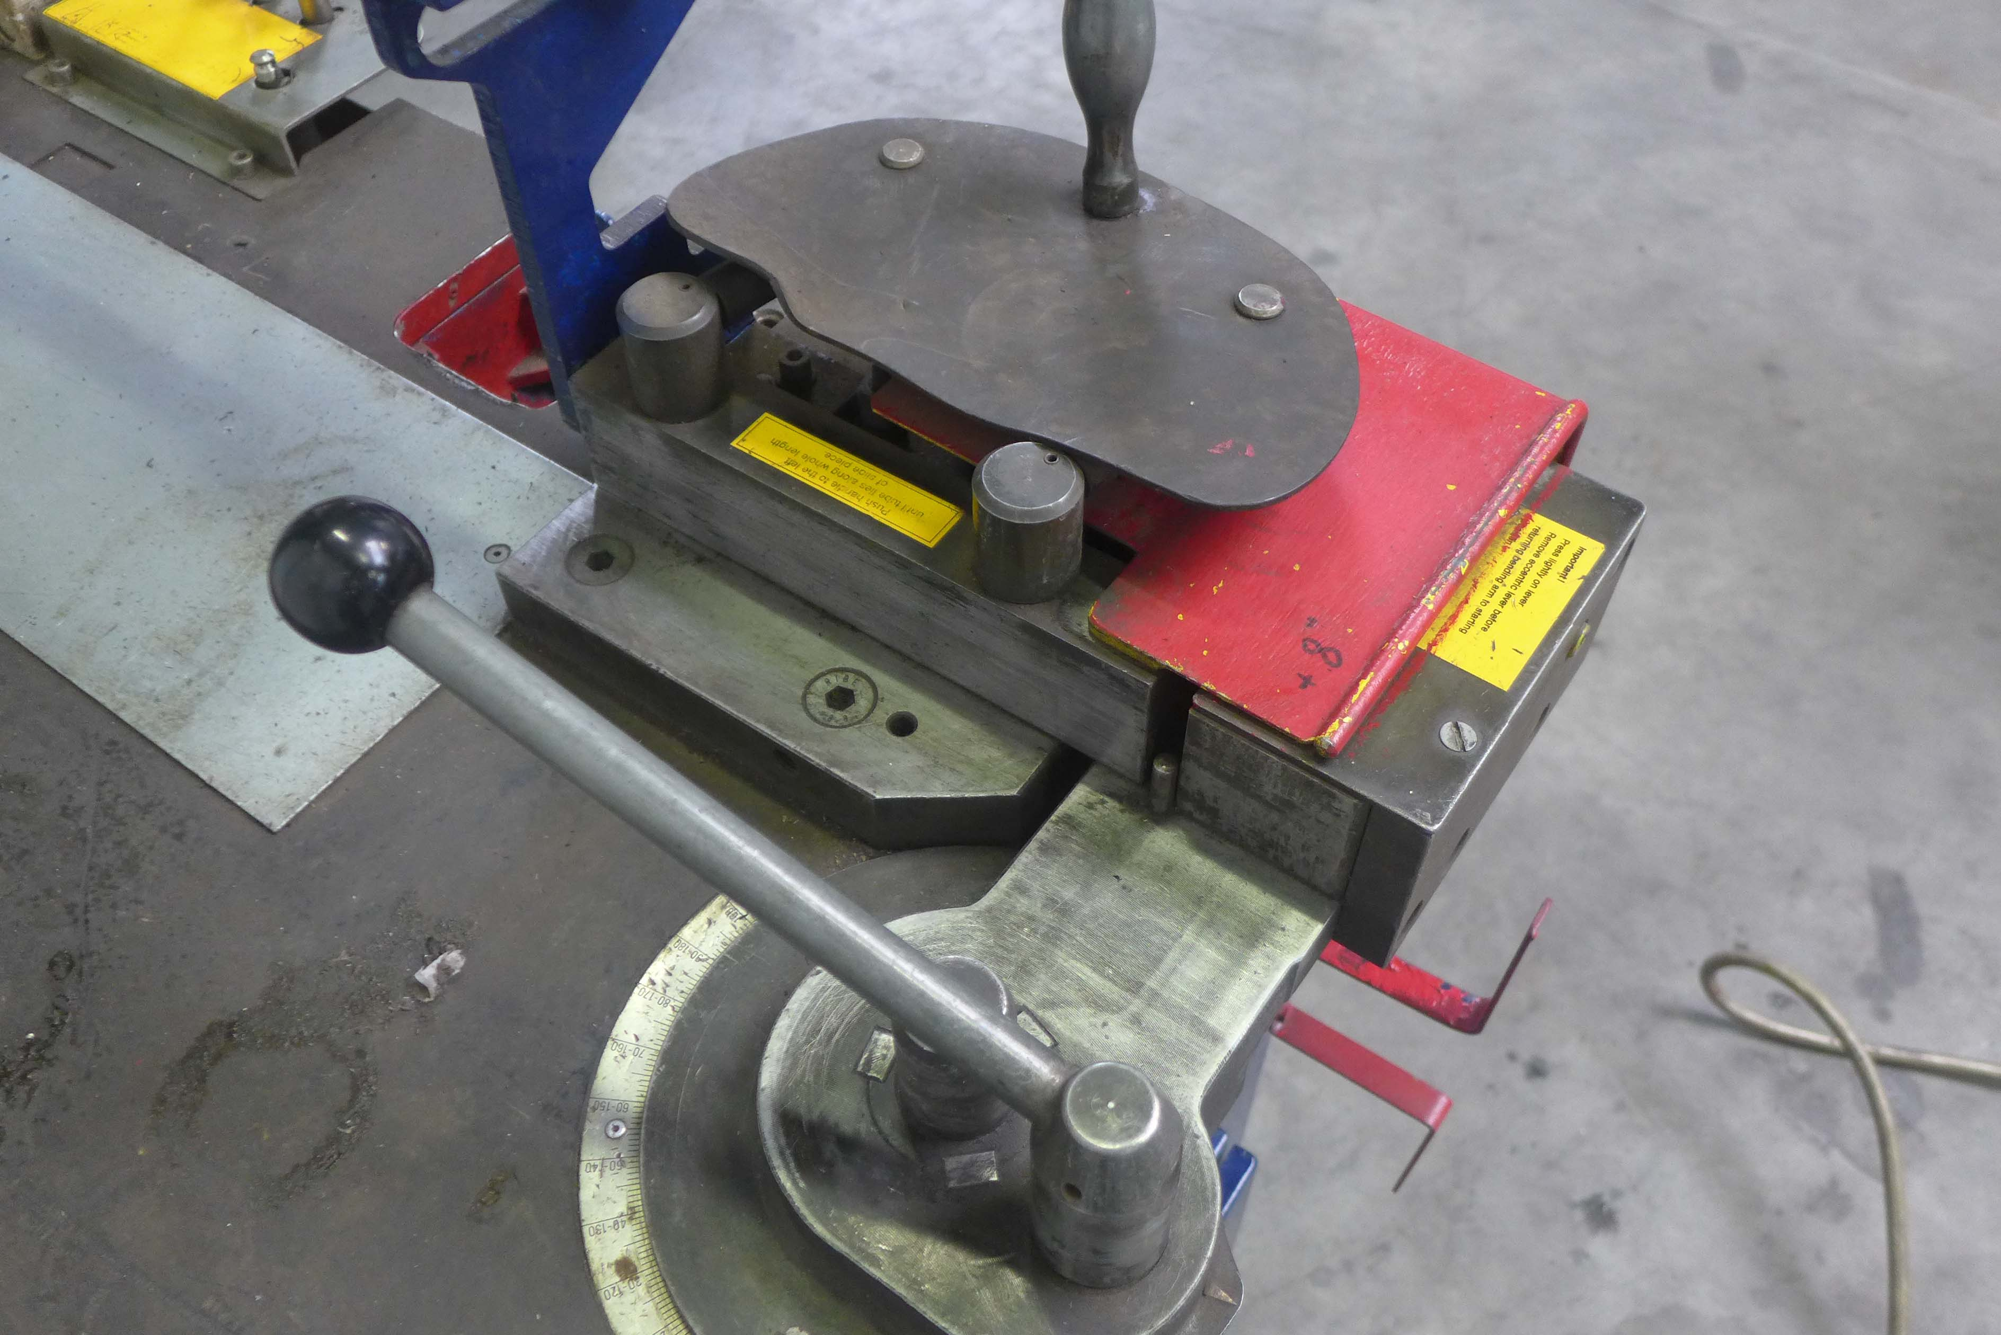
- Bending speed : 20˚/s
- Bending accuracy : ± 0.2˚

- Bending Capacity
Ø 6 up to 38 x 5 or 42 x 4 m

- Dimensions
- Length : 2.300
- Width : 800
- Height : 1.200

Features / Equipment
• Electric control with quadruple bending angle pre-selection and digital display
• Hydraulic mandrel retraction
• Circular saw with cooling and automatic feed
• Internal and external deburring unit
• Mobile and flexible to use

This mobile and flexibly usable processing machines meet all the requirements for safe hydraulic piping, from sawing over deburring, bending and cutting ring assembly up to flaring or chamfering of the pipe ends. The machines are extremely robust, easy to operate and absolutely reliable.

Please Note: The above information has been obtained to the best of our ability and belief from, and from the manufacturers where possible. It is given in good faith, but its accuracy can not be guaranteed. Accordingly, it will not form a representation or constitute contractual terms. We advise you to check any vital details!

